UP BikeShare Web Server
Project Description

Submitted to:

Prof. Ma. Rowena C. Solamo
Faculty Member
Department of Computer Science
College of Engineering
University of the Philippines, Diliman

Submitted by:
Kirzten Cassielle N. Marquez
Carlos Daniel S. Penaflorida
Alezon Maxine G. Valerio

In partial fulfillment of Academic Requirements
for the course
CS 191 Software Engineering I
of the
1st Semester, AY 2014-2015

Unique Reference:
The documents are stored in https://github.com/team-mvp/UP-BikeShare-Project.

Document Purpose:
This document states the entities, major functionalities, inputs and outputs needed and the clear context diagram and description of the project at hand.

Target Audience:
UP BikeShare administrators

Revision Control:
Revision Date | Person Responsible | Version  Number | Modification
08/25/15 | Alezon Valerio  Carlos Penaflorida  Kirzten Marquez | 1.0 | Initial Document; First draft of the Project Description  Some details might still be vague for the client hasn’t clearly decided on what they want the developers to do

Project Title: UP BikeShare Web Server

Description: This project focuses on the back end of the UP Bikeshare web application. It includes the majority of the main database interaction, administrative processes and commands, and overall analytics. It will have a simple interface prioritizing accessibility to functionalities and content over user aesthetics and the like.

Context Diagram:
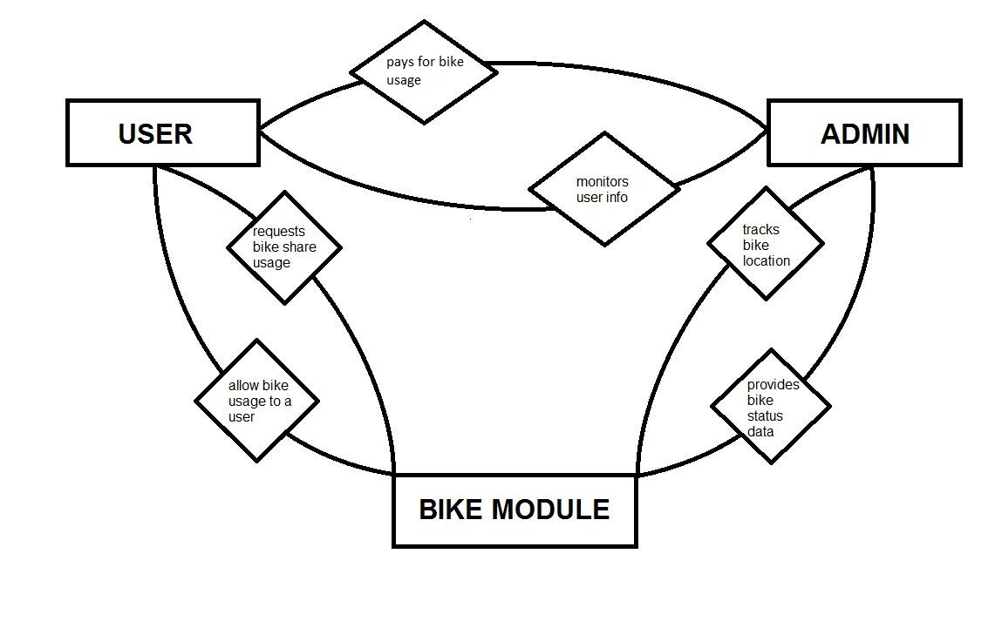

Entities:

1. Bike Modules - Hardware attached to the bikes that will send necessary data to the database that will be analyzed and interpreted by the web server and will then be displayed onto the Back-End web app for the administrators to see and check
2. Users - User ID, pin, accountabilities, rental/borrow time, past bikeshare records
3. Administrators - People to access the Web server

Major Inputs:

1. Bike ID, Location, Velocity - Data needed to be stored in the database and interpreted by the web server
2. User ID, Rental/Borrow Time, Accountabilities, Past BikeShare Records - Necessary to be able to track the users

Major Outputs:

1. Map location of bikes - Produces a map that track bikes
2. User information - User ID's, pins, accountabilities, past bikeshare records
2. Bike Velocity and interpretation of such velocity - Overspeeding, brakes are not working properly, etc.

Major Functionalities:

1. Admin tracks bike's location using a map
2. Admin tracks current bike status
3. Admin tracks user's delinquencies and accountabilities
4. Admin checks user’s past bikeshare records
5. Admin tracks available bikes

